**Appendix A.**

The following are sample runs for the three images referred to in our report.

**1. Image 1:** aesop_fox.png

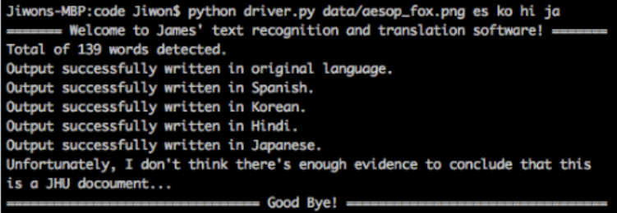

**Command line argument and standard out.**

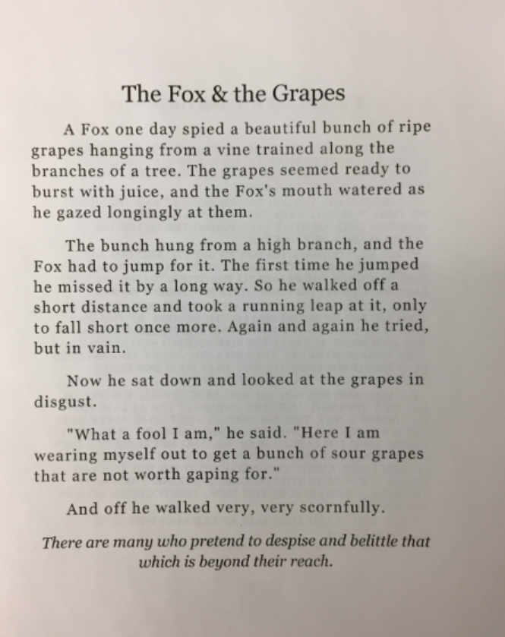

**Original input image** aesop_fox.png**, unprocessed.**

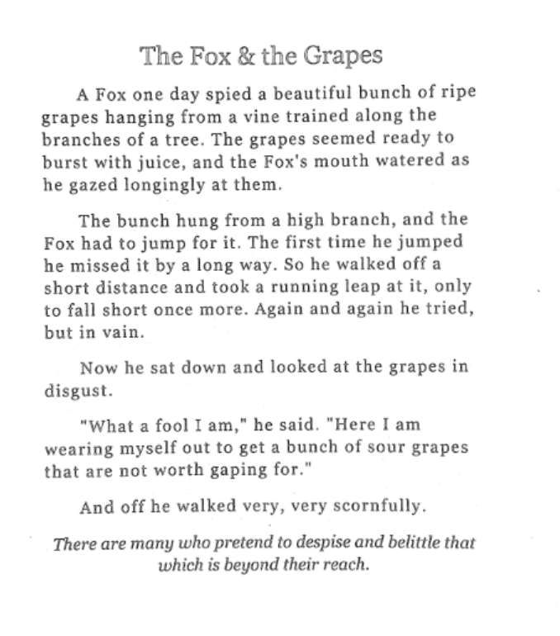

**Thresholded input image** aesop_fox_thresh.png**.**

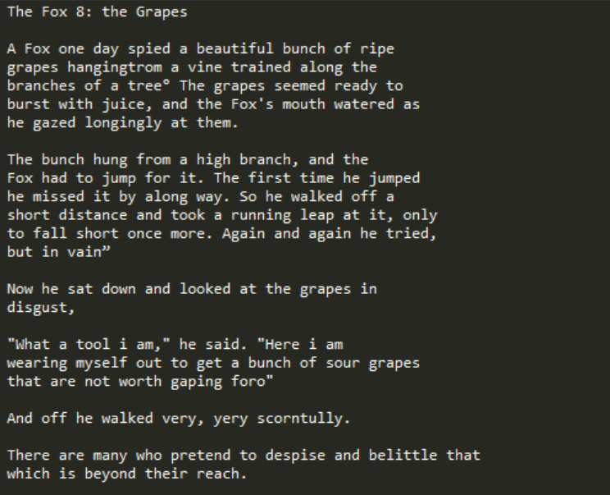

**Text output in English. (**aesop_fox_output.txt**)**

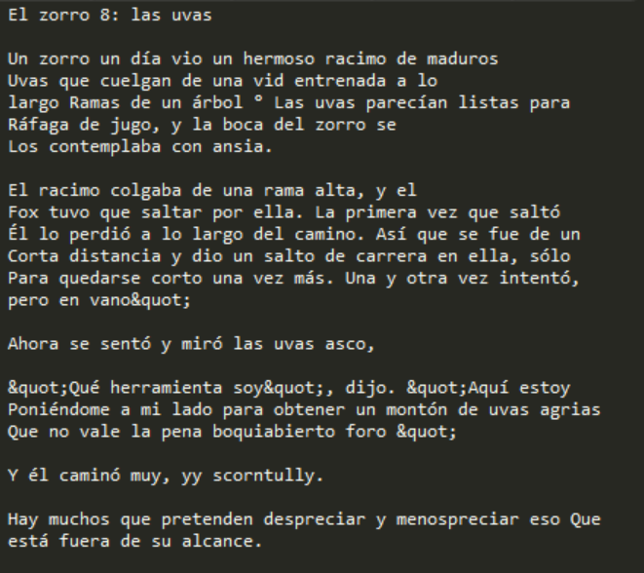

**Text output in Spanish. (**aesop_fox_output_es.txt**)**

**2. Image 2:** hand_cat.png

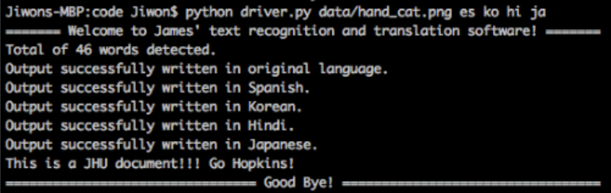

**Command line argument and standard out.**

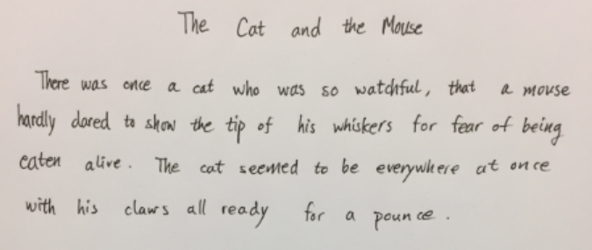

**Original input image** hand_cat.png**, unprocessed.**

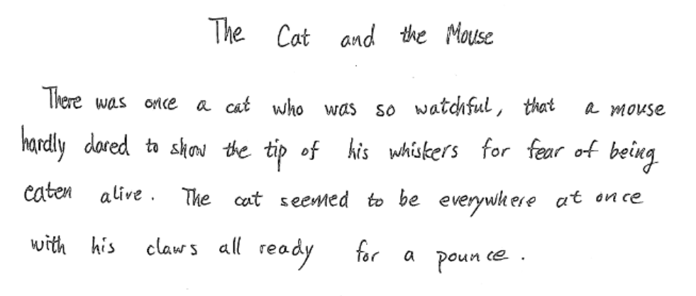

**Thresholded input image** hand_cat_thresh.png**.**

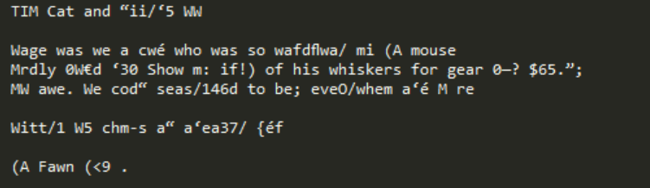

**Text output in English. (**hand_cat_output.txt**)**

**3. Image 3:** obama2.png

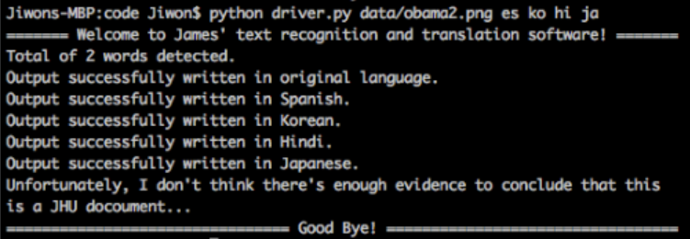

**Command line argument and standard out.**

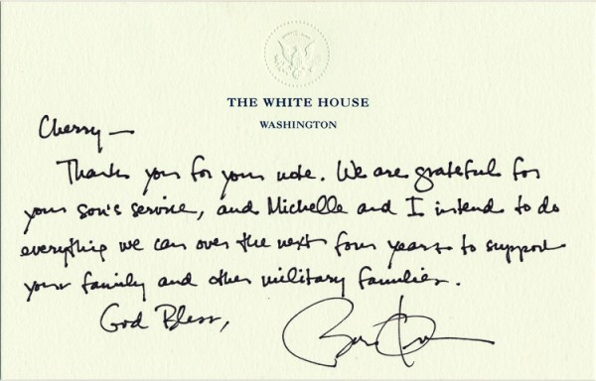

**Original input image** obama2.png**, unprocessed.**

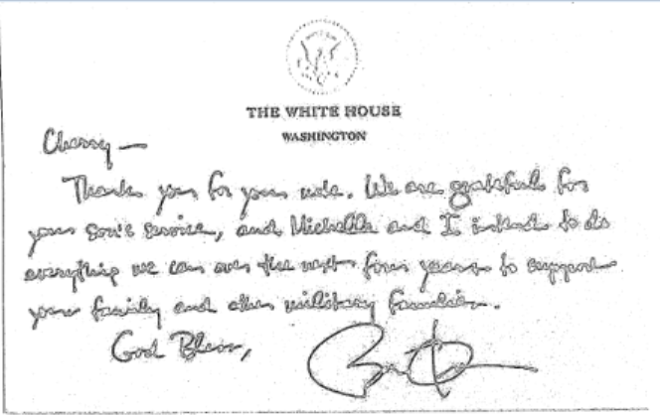

**Thresholded input image** obama2_thresh.png**.**

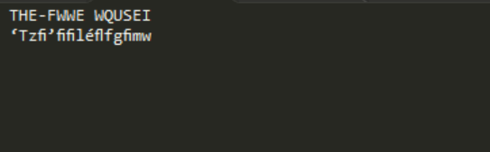

**Text output in English. (**obama2_output.txt**)**